Cancer Care Ontario
Specialized Services Oversight (SSO)
Interventional Radiology Appendices
(Program previously designated as Focal Tumour Ablation)
Version 1.0 R7
26-Sept-2016

Appendix-1: Facility Numbers

# | Program Title | Submitting Hospital | Facility Number
27 | Interventional Radiology | Halton Healthcare Services | 950
 |  | Hamilton Health Sciences Centre - JCC | 942
 |  | Kingston Health Sciences Centre (KHSC) | 978
 |  | Lakeridge Health | 952
 |  | London Health Sciences Centre - University Hospital | 899
 |  | London Health Sciences Centre - Victoria Hospital | 717
 |  | London Health Sciences Centre | 936
 |  | North York General Hospital | 632
 |  | Royal Victoria Regional Health Center | 606
 |  | Sinai Health System | 976
 |  | St. Joseph’s Healthcare, Hamilton | 674
 |  | St. Joseph’s Health Centre, Toronto | 898
 |  | Grand River Hospital | 930
 |  | Sunnybrook Health Sciences Centre | 953
 |  | The Ottawa Hospital | 958
 |  | Trillium Health Partners | 975
 |  | University Health Network | 947
 |  | Windsor Regional Hospital | 933
 |  | Health Sciences North | 959
 |  | St. Michael’s Hospital | 852

Appendix-2: MOHLTC Master Numbering System
The Master Numbering System has been developed for the purpose of bringing together all Health Facilities and Programs under one system of identification. The list is a composite of health and health related units, facilities, clinics, programs and services. Each such organization has been assigned a unique four digit identifying code.
(For details, please refer Cancer Care Ontario's Data Book - 2012-2013, Appendix A: MOHLTC Master Numbering System, at link https://www.cancercare.on.ca/ext/databook/db1213/documents/Appendix/CCO_Appendix_A_APR_12.pdf).

Appendix-3: Valid 2-digit Postal Codes
(Source: Cancer Care Ontario's Data Book - 2012-2013, Appendix B - Province and State codes, at link https://www.cancercare.on.ca/ext/databook/db1213/databook.htm).

The table below provides list of valid 2 digit postal codes for province and State codes.
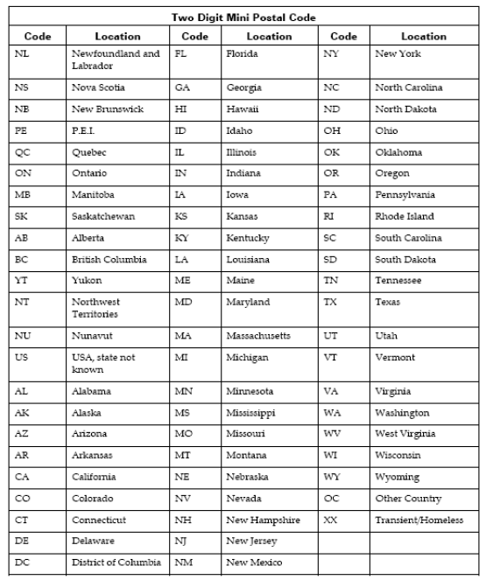

This corresponds to appendix 3 on ALR
This corresponds to appendix 13 on ALR
This corresponds to appendix 11 on ALR

